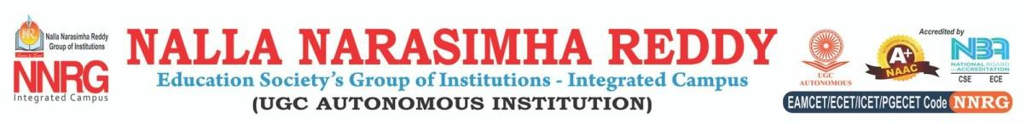
SCHOOL OF ENGINEERING
DEPARTMENT OF COMPUTER SCIENCE & ENGINEERING

TITLE: Autism Spectrum Disorder analysis for toddlers.
BATCH NO: B-20
GUIDE NAME: Mrs.G.Manasa
ABSTRACT :
Autism Spectrum Disorder (ASD) is a neuro-developmental condition that affects communication, social interaction, and behavior. Early detection plays a crucial role in improving outcomes through timely interventions. This project aims to develop a web-based autism screening tool that collects responses to 10 key behavioral questions and uses a trained machine learning (ML) model to assess ASD risk levels. Based on the responses, the system will classify the result as "Mild," "Severe," or "No ASD Traits" and provide precautionary recommendations. The project integrates data preprocessing, feature selection, and predictive modeling to enhance accuracy. A user-friendly interface will allow parents, caregivers, and clinicians to conduct preliminary assessments.
The system leverages historical screening data to train an ML model, ensuring reliable predictions. The model will be optimized for accuracy and efficiency, enabling real-time responses on the web interface. Additionally, it will provide users with precautionary steps based on the severity of detected ASD traits, guiding them toward appropriate next steps, such as seeking professional evaluation. By combining technology with healthcare screening, this project aims to offer an accessible and effective early intervention tool for autism awareness and detection.
Keywords: Autism Screening, Machine Learning, ASD Detection, Early Diagnosis, Behavioral Analysis, Expected Treatment Level.

TEAM MEMBERS: GUIDE SIGNATURE
Shaik Irfan Baba (227Z1A66B5)
Vinjamuri Siri Vennela (227Z1A66C6)
Sarva Darshan (227Z1A66B4

